|  |
| --- |
| **COMPUTER PROGRAMMING** |
| **CEP PROJECT REPORT BANK MANAGEMENT SYSTEM** |
|  |



Table of Contents

**CHAPTER 13**

Introduction3

**CHAPTER 23**

2.1 Functional Operation 3

2.2 Non Functional Operation 4

2.3 Requirements 4

**CHAPTER 35**

Design of system 5

**CHAPTER 4**

Screenshots**6-9**

**CHAPTER 5**

Conclusion **10**

* **INTRODUCTION:**

The project that was given to us was to create a bank management system . In this software a users data will be received and modified according to his own needs. These kinds of software are used in Banks.

**___________________________________________________________________**

* **Functional Operations:**

All of these functions are present in this project:

* Add new account
* Deposit amount
* Withdraw amount
* Balance enquiry
* List of all account holders in bank
* Close or delete an account
* Modify detail of an account
* Exit
* **Non Functional Operations:**

Functions which are not present in this project but are a part of Bank management are :

* Money transfer
* Loan payments

**___________________________________________________________**

* **Requirments to run this software:**

As this is just a normal program it does not need any high end sofware or harware requirments but in actual practice a lot of privacy is at risk so powerfull machines and coding techniques are used to secure the data of the customers.

* FLOWCHART :

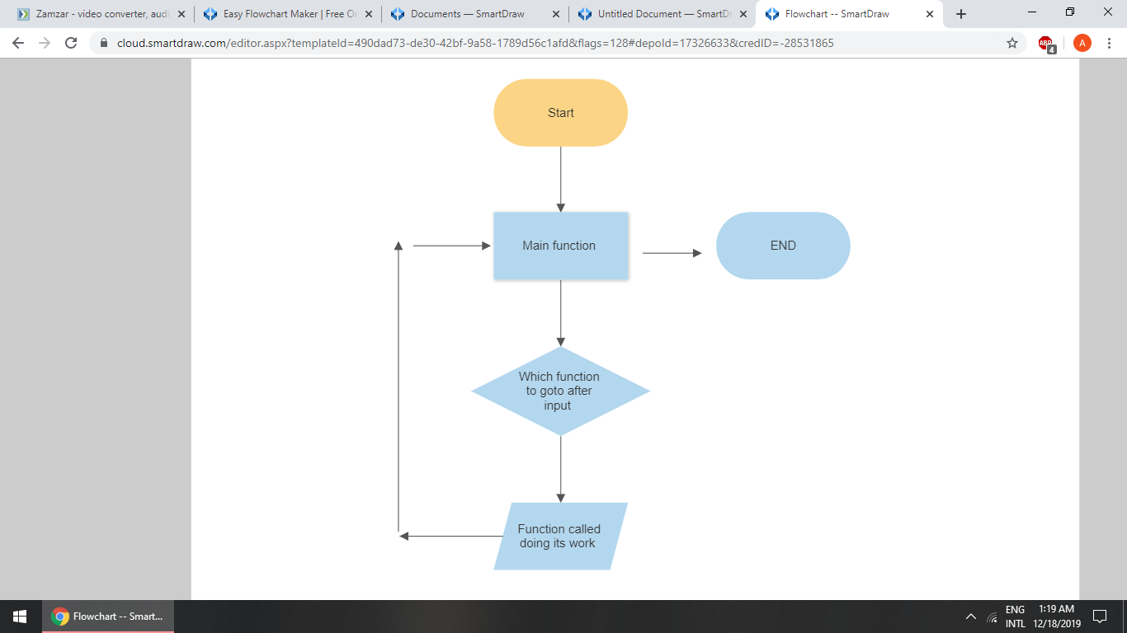

* SCREENSHOTS :

MAIN VIEW:

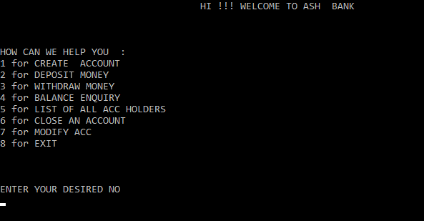

CASE 1 :

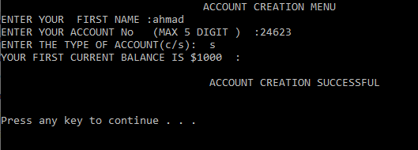

CASE 2 :

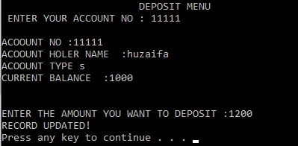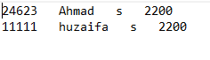

CASE 3 :

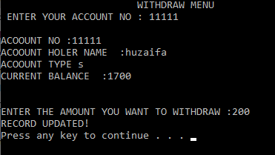

CASE 4:

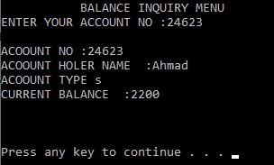

CASE 5 :

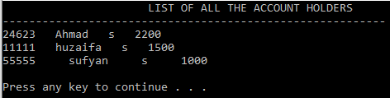

CASE 6:

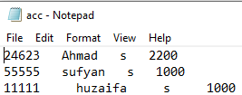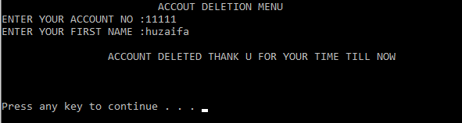

CASE 7 :

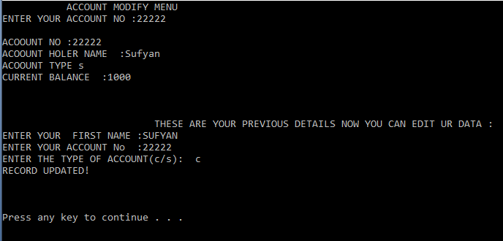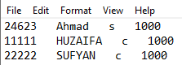

CASE 8 :

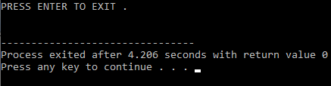

____________________________________________________________

**CONCLUSION:**

So we came to a conclusion that programming is not all about correct syntax , it needs logic and everyone can use different logic to get to the required answer . This activity improved a lot of our errors and confusions related to porgramming .